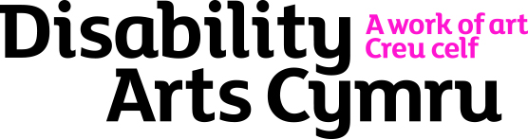
Disability Arts Cymru
Equal Opportunities Monitoring Form
Disability Arts Cymru is committed to equality of opportunity and seeks to promote diversity. As part of this commitment we monitor all job applications to ensure we are attracting and selecting applicants from all sections of the community. It is for this reason that we would like you to complete this form. The information collected helps us to evaluate our effectiveness as an equal opportunities employer and will only be used for that purpose.
This form will be detached and kept separately from your job application, and will be anonymous. The recruitment panel will not see it at any stage of the shortlisting and recruitment process, and the form is NOT part of the selection process.
If you feel that you want to answer all the question, please do, but you do not have to. Please tick as appropriate and as far as you are willing.

What is your gender?
Do you consider yourself to be a disabled person? | Yes No
What age are you? | 16-21 22-35 36-45 46-55 56+
How would you describe your nationality? | Please describe if other
How would you describe your ethnic origin? | A. White/Mixed  Please describe if other  B. Asian/ Asian British  Please describe if other  C Black/ Black British  Please describe if other  D. Chinese or other Ethnic Group  Please describe if other  E. I do not wish to declare my ethnic group

Are there any other ways you would describe yourself that are not on this form?

Do you identify as
Thank you for completing this form. Please include it with your application form.

